1.Setting up JUnit
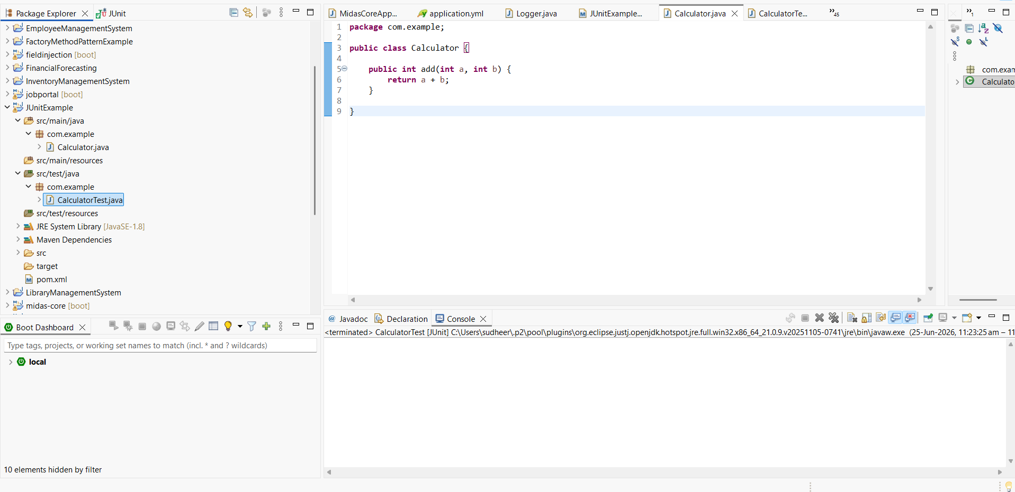
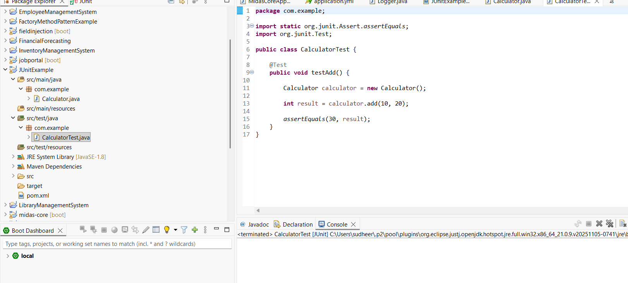
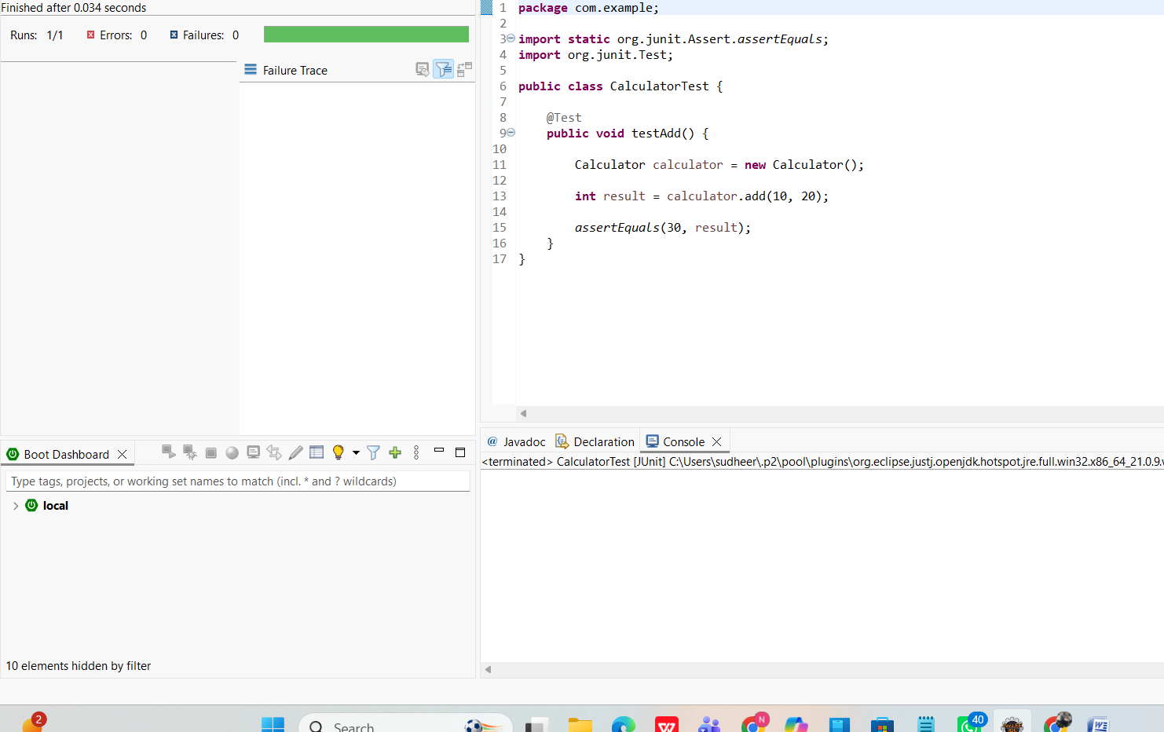
2.Assertions in JUnit
AssertionsTest.java
package com.example;

import static org.junit.Assert.*;
import org.junit.Test;

public class AssertionsTest {

@Test
public void testAssertions() {

assertEquals(5, 2 + 3);

assertTrue(5 > 3);

assertFalse(5 < 3);

assertNull(null);

assertNotNull(new Object());
}
}
Output:
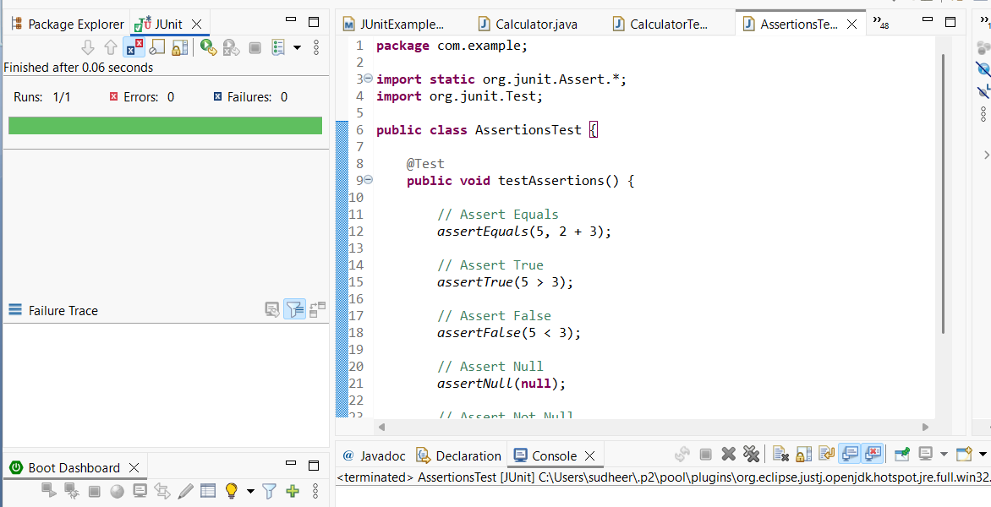
Exercise4:
Output: 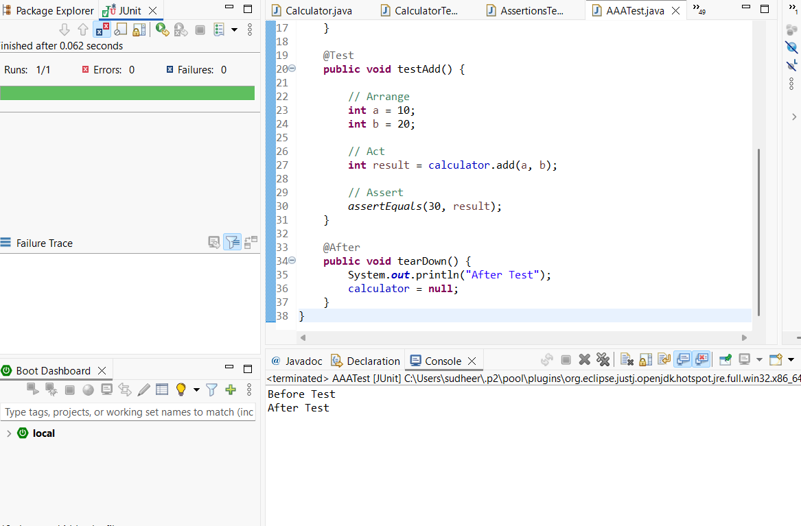
Code:
package com.example;

import static org.junit.Assert.assertEquals;

import org.junit.After;
import org.junit.Before;
import org.junit.Test;

public class AAATest {

Calculator calculator;

@Before
public void setUp() {
System.out.println("Before Test");
calculator = new Calculator();
}

@Test
public void testAdd() {

int a = 10;
int b = 20;

int result = calculator.add(a, b);

assertEquals(30, result);
}

@After
public void tearDown() {
System.out.println("After Test");
calculator = null;
}
}

